DOCUMENT 26 — Performance & Device Optimization
Visionary Internal · v1.0 · The ₹8,000-Android contract (R8)

The paying student is not on Wi-Fi with a flagship. Every budget below is a CI gate:
a PR that breaks a budget fails the build.

1. Budgets & enforcement

Metric | Budget | Enforced at
TTI (cold, 4G) | ≤2.5s | CI bundle budget + CDN
TTFT (teaching turn) | ≤200ms p95 | gateway SLO + streaming + prompt/KV cache
3D frame rate | 30fps | runtime probe on device lab
3D first frame | ≤1.5s | scene protocol (Doc 21)
Scene asset load | ≤2s | Draco + LOD + R2/CDN prefetch
SCM read | ≤50ms | Redis hot path (R3)
BKT update | <100ms | batched write
App RAM footprint | ≤250MB | texture compression + lazy routes
Background activity | zero polling | consented push only

2. Device tiering

Tier | Probe | Experience
T1 | ≥4GB RAM + WebGL2 | full 3D, high LOD
T2 | 3GB RAM | medium LOD, compressed textures
T3 | <3GB RAM or no WebGL | 2D SVG fallback per concept (Doc 21)
device_tier set at onboarding, re-probed at runtime; never a user-visible setting.

3. Techniques
Per-app code splitting + route prefetch · font subsetting per script · WebP/AVIF ·
SSE streaming with cancel · vLLM continuous batching + AWQ 4-bit (Phase 3) ·
offline queue flush on reconnect · image/asset immutable caching at edge.

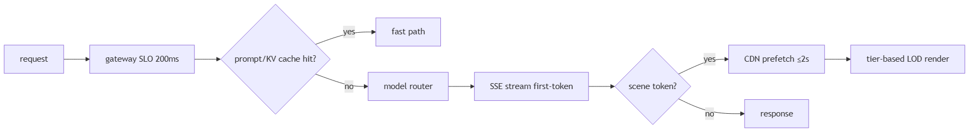

OKF
KF1 all budgets green in CI on merge · KF2 T3 devices never crash on a 3D concept ·
KF3 p95 TTFT ≤200ms on 4G field sample · KF4 offline lesson resumes without network ·
KF5 battery: no background wake-locks in release build.

